 | 
COUNCIL ASSESSMENT REPORT
NORTHERN REGIONAL PLANNING PANEL

PANEL REFERENCE & DA NUMBER | PPSNTH-128 - DA2021/47
PROPOSAL | Erection of a 5MW Solar Farm
ADDRESS | Lot 2 DP 707260 and Lot 1 DP 705438 – Rosedale Road Ashley
APPLICANT | SLR Consulting Australia Pty Ltd
OWNER | Mr P J Kennedy
DA LODGEMENT DATE | 16 September 2021
APPLICATION TYPE | Development Application
REGIONALLY SIGNIFICANT CRITERIA | Clause 5a Schedule 6 of the Planning Systems SEPP:  Private infrastructure and community facilities over $5 million  Development that has a capital investment value of more than $5 million for any of the following purposes—  (a) air transport facilities, electricity generating works, port facilities, rail infrastructure facilities, road infrastructure facilities, sewerage systems, telecommunications facilities, waste or resource management facilities, water supply systems, or wharf or boating facilities,  (b) affordable housing, child care centres, community facilities, correctional centres, educational establishments, group homes, health services facilities or places of public worship.
CIV | $6,940,420 (excluding GST)
CLAUSE 4.6 REQUESTS | Not applicable
KEY SEPP/LEP | - State Environmental Planning Policy (Planning Systems) 2021  - Part 2.4 Regionally Significant Development; Schedule 6  - State Environmental Planning Policy (Resilience and Hazards) 2021  - Chapter 4 Remediation of Land;  - State Environmental Planning Policy (Transport and Infrastructure) 2021  - Chapter 2 Infrastructure  - Draft Remediation of Land SEPP;  - Draft SEPP (Environment);  Moree Plains Local Environmental Plan 2011;
TOTAL & UNIQUE SUBMISSIONS KEY ISSUES IN SUBMISSIONS | Nil
DOCUMENTS SUBMITTED FOR CONSIDERATION | Statement of Environmental Effects  Appendix A – Development Plans  Appendix B – Stormwater Management Plan  Appendix C – Development Control Plan Assessment  Appendix D – Traffic Impact Assessment  Appendix E – AHIMS result  Appendix F – Visual Impact Analysis  Appendix G – Acoustic Assessment  Appendix H – Capital Investment Value  Appendix I – Waste Management Plan  Flood Impact Assessment
SPECIAL INFRASTRUCTURE CONTRIBUTIONS (S7.24) | N/A
RECOMMENDATION | Approval
DRAFT CONDITIONS TO APPLICANT | No
SCHEDULED MEETING DATE | 18 May 2022
PLAN VERSION | 7 May 2021 Revision B
PREPARED BY | Katrina Walker – Perception Planning
DATE OF REPORT | 6 May 2022

EXECUTIVE SUMMARY
The development application (DA 2021/0047) is part of Providence Asset Group’s solar initiatives being rolled out across regional Australia and seeks to construct:

- Installation of 5MW grid-connected solar PV panels consisting of approximately 13,356 panels with name plate rating of 540W. Panels measure approximately 2.26m x 1.13m with 600mm clearance above the natural ground level.
- The PV arrangement will consist of 159 ground mounted single axis trackers with north-south orientation.
- Panels will be separated by approximately 6.5m.
- PV mounting structure will comprise of steel posts driven approximately 1.5m below surface level.
- Connection to existing Country Energy Substation at Carnarvon Highway.
- Construction of Power Conversion Station consisting of inverters, transformer, switchgear and auxiliary plant.
- Construction of security fencing with a height of 2.3m surrounding the solar farm. The security fencing is offset 10m from the PV array.
- Construction of stormwater management system consisting of an onsite detention basin, holding a total volume of 179m³ supported with a low flow outlet.
- Earthworks to establish access road, drainage swales and batters, laydown area and detention basin.

The site is legally identified as Lot 2 in Deposited Plan 707260 and Lot 1 in Deposited Plan 7015438, commonly identified as Rosedale Road, Ashley. The subject area is a rectangular portion of the site located in the northwest corner of the allotment. The overall site is triangular in shape with an area measuring approximately 247ha; the subject area measures approximately 15.2 ha.

The site is flat in topography and no known watercourses or waterbodies traverse the site. The land is separated by an internal road. East of the road the land has been cultivated for agricultural purposes. West of the road appears to be unmanaged vegetation. A small shed and water tank are located approximately halfway along the southwest boundary in the unmanaged vegetation.

The site is a split zone identified as being mapped as RU4 – Primary Production Small Lots and RU1 – Primary Production. The land bordering the southeast and north boundaries is identified as zone RU1. The land is currently utilised for cropping. The land along the southeast boundary is identified as RU1, SP2 – Infrastructure and RU5 – Village. The SP2 land is identified on the MPLEP 2011 Map LZN_004A as Public Utility Undertakings. The land mapped RU5 is the township of Ashely. No other known solar farms are present in the locality. The Ashely 66/22Kv Zone Substation is located approximately 2.4km north-west of the site.

State Environmental Planning Policy (Planning Systems) 2021 (‘Systems SEPP’) applies to the proposal as it identifies if development is regionally significant development. In this case, pursuant to Clause 2.19 of Systems SEPP, the proposal is a regionally significant development as it satisfies the criteria in Clause 5(a) of Schedule 7 of the SRD SEPP as the proposal is development for electricity generating works with a CIV over $5 million. The purpose of the State Environmental Planning Policy (Transport and Infrastructure) 2021 (‘T&I SEPP’) is to facilitate the effective delivery of infrastructure across the state and identifying matters to be considered in the assessment of developments adjacent to particular types of development. The proposed development is for a 5MW solar electricity generating farm with connection to the Country Energy Substation. Pursuant to Clause 2.36(1)(b) development for the purpose for electricity generating works may be carried out by any person with consent on land in a prescribed rural, industrial or special use zone. Both Zone RU1 and RU4 are identified as prescribed zones under Clause 2.35 – Definitions. Accordingly, the development is permissible with consent under Clause 2.36(1)(b). The proposal is considered to be consistent with these zone objectives detailed under the Moree Plains Local Environmental Plan 2011 for the following reasons:

- The development proposal does not result in the fragmentation of agricultural land nor result in land use conflict between adjoining zones;
- The development proposal encourages sustainable energy production and diversifies the economic and commercial enterprises and employment opportunities within the municipality; and
- The rural character of the locality is not significantly compromised as a result of the development.

Accordingly, the subject site is deemed suitable for the proposed development.
There were concurrence requirements from agencies for the proposal, accordingly the application was referred to ARTC, Essential Energy and RFS. ARTC did not respond to the referral, accordingly it is deemed that there is no adverse impact on the railway corridor. The Reflectivity Statement identified that nuisance glare may result during construction or maintenance, accordingly, this issue has been resolved through the implementation of the recommendations made with the SLR Visual Impact Assessment Report and Conditioned accordingly. Essential Energy did not object to the development proposal and RFS issued General Terms of Approval. These matters are resolved through consent conditions. The application is not integrated development pursuant to Section 4.46 of the Environmental Planning and Assessment Act 1979 (‘EP&A Act’).

A briefing was held with the Panel on 16 February 2022 where key issues were discussed including:

- Land clearing on the site undertake since 2015 without relevant approvals
- Flooding
- Bushfire
- Stormwater management, and
- Visual impact

In response to the key issues raised in the briefing the following is made:

- Land clearing - The Biodiversity Conservation Department (BCD) identified that had an application been made to remove the vegetation it would have been likely to be approved. The BCD deemed the vegetation to be of low biodiversity value, accordingly, no further action was required, and the matter closed. Accordingly, no compensatory planting is required.

Considering the low ecological value of the vegetation, it was not considered necessary to Condition the existing vegetation on western boundary for retention. Any future removal of this vegetation would require BCD’s concurrence.

- Flooding - A flood impact assessment was prepared and determined the site was flood free land during a 1% AEP event. In the more rare and extreme events, minor inundation is likely. The flood characteristic was identified as shallow low hazard flood water. Accordingly, given the proposal is for a non-habitable structure, the development is considered suitable for the flood characteristic of the land and does not result in any substantial risk to life or property during a rare or extreme flood event.
- Bush fire - General Terms of Approval (GTAs) were issued by RFS to manage risk to property and infrastructure as a result of bushfire. These matters are conditioned as part of the consent.
- Stormwater flows - A request for further information was issued to the proponent to respond to Council’s concerns surrounding post development flows. The response from the proponent was to the satisfaction of Council, whereby peak flow overland flows were not increased as a result of the proposal. To this extent, stormwater can be successfully managed on site.
- Visual impacts and lighting - The development is not identified to result in any visual impacts that require mitigation measures. Whilst the vegetation to the west of the development obstructs views to the development from Carnarvon Highway, the distance from the classified road and height of the structures is considered reasonable that no condition of consent was required to retain the existing vegetation.

Night illumination was indicated within the Development Application. Clarification from the proponent was sought and no night illumination is consented under this application. A future Development Application is required to install night illumination.

Following consideration of the matters for consideration under Section 4.15(1) of the EP&A Act, the provisions of the relevant State environmental planning policies, the MLEP 2012 and the MDCP, the proposal is supported. Following a detailed assessment of the proposal, pursuant to Section 4.16(1)(a) of the EP&A Act, DA 2021/0047 is recommended for approval subject to the conditions contained at Attachment 2 of this report.
- THE SITE AND LOCALITY

  - The Site
The site is legally identified as Lot 2 in Deposited Plan 707260 and Lot 1 in Deposited Plan 7015438, commonly identified as Rosedale Road, Ashley. The site in its surrounding locality is shown in Figure 1. The subject area is a rectangular portion of the site located in the northwest corner of the allotment, shown in Figure 2. The overall site is triangular in shape with an area measuring approximately 247ha; the subject area measures approximately 15.2 ha.

The site is flat in topography and no known watercourses or waterbodies traverse the site. The land is separated by an internal road. East of the road the land has been cultivated for agricultural purposes. West of the road appears to be unmanaged vegetation. A small shed and water tank are located approximately halfway along the southwest boundary in the unmanaged vegetation.

The site is bounded by Werris Creek to Mungindi railway to the southwest; Rosedale Road to the southeast and agricultural land to the north. The township of Ashley is located approximately 2km as the crow flies from the subject area. Primary access to the site is via Rosedale Road. Rosedale Road is identified as a local government road under the maintenance of Moree Plains Shire Council.
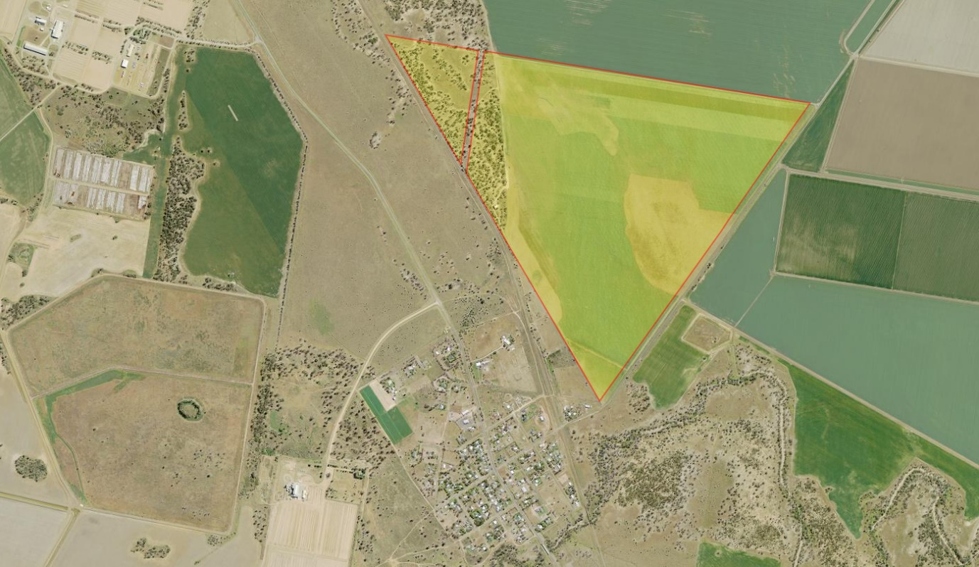
Ashely township
Carnarvon Highway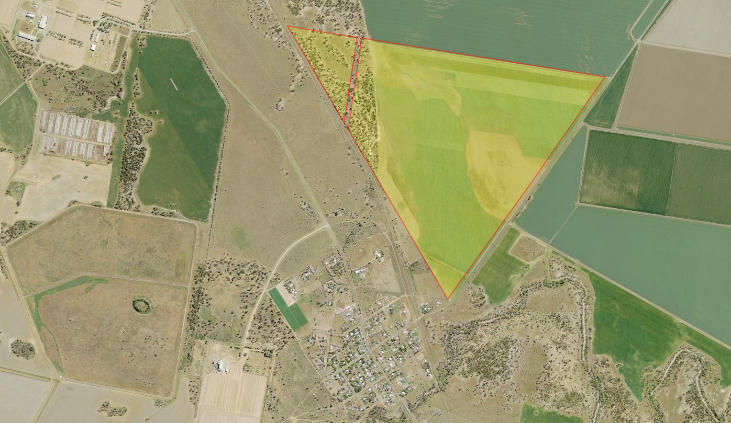
Site (Lot 2 DP707260)
Werris Creek Mungindi Railway
Figure 1: Site within the surrounding locality (SixMaps, adapted by author, 2021)
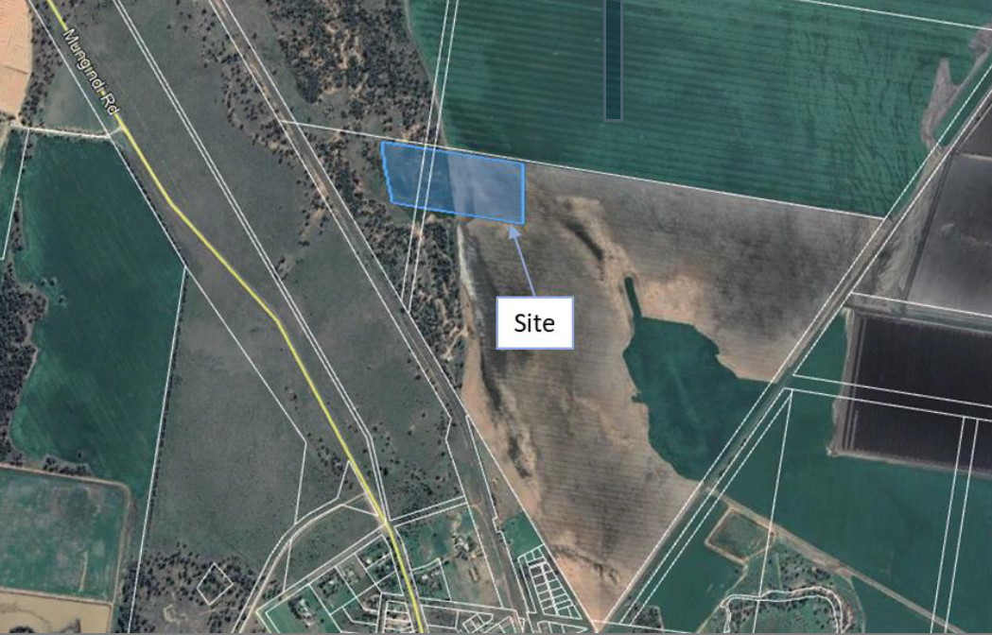
Figure 2: Subject area within site measuring approximately 15 ha on north boundary (SLR, 2021)

  - The Locality
The site is a split zone identified as being mapped as RU4 – Primary Production Small Lots and RU1 – Primary Production. The land bordering the southeast and north boundaries is identified as zone RU1. Aerial imagery suggests the land is farmed in some capacity.

The land along the southeast boundary is identified as RU1, SP2 – Infrastructure and RU5 – Village. The SP2 land is identified on the MPLEP 2011 Map LZN_004A as Public Utility Undertakings. The land mapped RU5 is the township of Ashely.

No other known solar farms are present in the locality. The Ashely 66/22Kv Zone Substation is located approximately 2.4km north-west of the site.

- THE PROPOSAL AND BACKGROUND

  - The Proposal
The development proposal is part of Providence Asset Group’s solar initiatives being rolled out across regional Australia. The proposal includes:

- Installation of 5MW grid-connected solar PV panels consisting of approximately 13,356 panels with name plate rating of 540W. Panels measure approximately 2.26m x 1.13m with 600mm clearance above the natural ground level.
- The PV arrangement will consist of 159 ground mounted single axis trackers with north-south orientation.
- Panels will be separated by approximately 6.5m.
- PV mounting structure will comprise of steel posts driven approximately 1.5m below surface level.
- Connection to existing Country Energy Substation at Carnarvon Highway.
- Construction of Power Conversion Station consisting of inverters, transformer, switchgear and auxiliary plant.
- Construction of security fencing with a height of 2.3m surrounding the solar farm. The security fencing is offset 10m from the PV array.
- Construction of stormwater management system consisting of an onsite detention basin, holding a total volume of 179m³ supported with a low flow outlet.
- Earthworks to establish access road, drainage swales and batters, laydown area and detention basin.

Construction is anticipated to occur over 6 months with approximately 30 personnel. Operation of the facility will be 4 hours a day, 7 days a week with no permanent staff. Maintenance will be taken on a daily or as need basis.

The subject area measures 617m along the north boundary; 252m along the east boundary; 587m along the south boundary and 259m along the west boundary. The subject area is located on the north boundary of the site with the security fencing offset 10m from the boundary. The offset from west boundary of subject area to Carnarvon Highway measures approximately 900m. Offset from southwest corner of subject area to Carnarvon Highway measures approximately 670m. Offset from southern boundary of subject area to Ashley township measures approximately 1.6km. Offset from eastern boundary of subject area to Rosedale Road measures approximately 1.6km.

The proposed development is shown in Figure 3 and Figure 4 below and contained within Appendix A of the Development Application package.

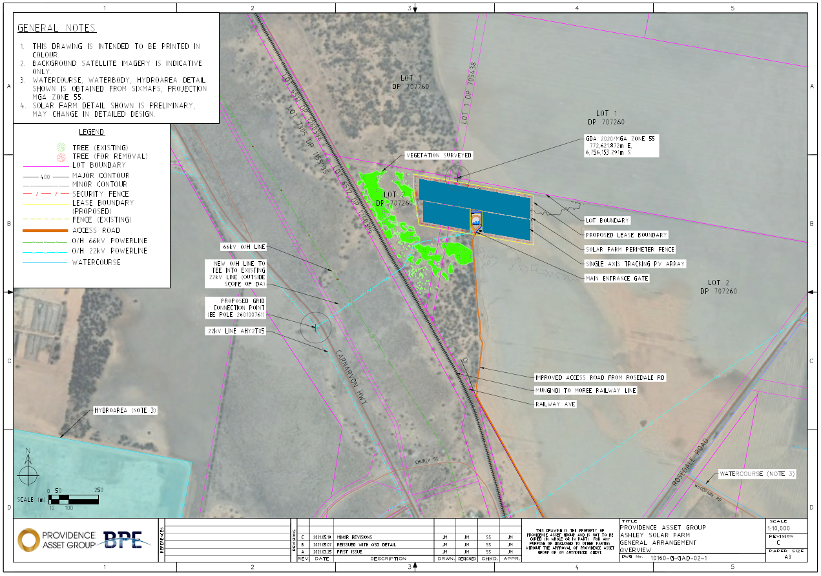
Figure 3: Solar farm site location (BPE Providence Asset Group, Rev C, 2021)
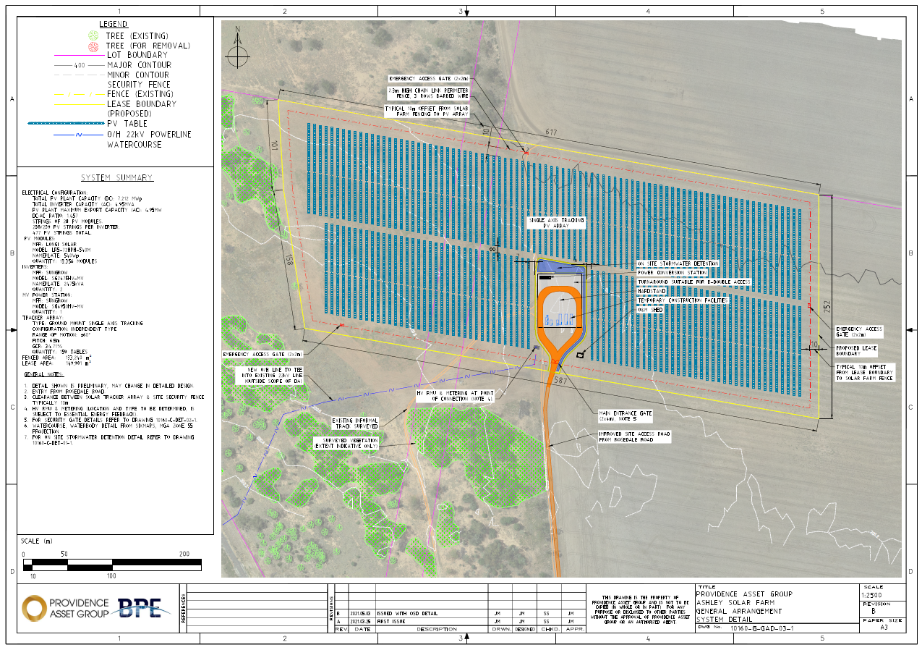
Figure 4: Solar farm site Layout (BPE Providence Asset Group, Rev B, 2021)
Table 1: Development Data
Control | Proposal
Site area | 15 ha
GFA | NA
FSR (retail/residential) | NA
Clause 4.6 Requests | No
No of apartments | NA
Max Height | Trackers at full tilt measure ~2.58m above NGL. Clearance of PV panel is 600mm from NGL.
Landscaped area | Utilising existing vegetation. No formal landscaping provided.
Car Parking spaces | No formal parking spaces provided. Carparking for vehicles undertaking maintenance is proposed on the hardstand surface.
Setbacks | West boundary to Carnarvon Highway measures approximately 900m.  Southwest corner to Carnarvon Highway measures approximately 670m.  Southern boundary to Ashley township measures approximately 1.6km.  Eastern boundary to Rosedale Road measures approximately 1.6km.

  - Background

As detailed in the SoEE, a pre-lodgement meeting was requested prior to the lodgement of the applicant. However, Council deemed the pre-development application meeting unnecessary. Formal pre-development application advice was issued by Council (via email from Shaun Yong) on 10 March 2021 where various issues were discussed. A summary of the key issues discuss according to the proponent is listed below (Council have no record of the pre-DA Advice)

- Land permissibility;
- Land use compatibility;
- Amenity;
- Aboriginal Heritage;
- Flooding;
- Bushfire Management;
- Biodiversity;
- Site Drainage;
- ARTC;
- Noise;
- Dust; and
- Reflectivity.
The development application was lodged on 16 September 2021. A chronology of the development application since lodgement is outlined below including the Panel’s involvement (briefings, deferrals etc) with the application:

Table 2: Chronology of the DA
Date | Event
16 September 2021 | DA lodged
7 October 2021 | Exhibition of the application
29 September 2021 | DA referred to external agencies
6 December 2021 | Request for Information from Council to applicant
16 February 2022 | Panel briefing
15 March 2022 | Applicant provided additional information on land clearing activities
27 April 2022 | Applicant provided Flood Impact Assessment for the proposal

  - Site History
The site has historically been cultivated for farming operations. It was noted that aerial imagery showed a vegetation buffer along the west boundary, however part of this vegetation has been cleared as part of ongoing farming practice. As such this development application does not seek to remove any vegetation.

There are no concurrent applications currently being considered

- STATUTORY CONSIDERATIONS
When determining a development application, the consent authority must take into consideration the matters outlined in Section 4.15(1) of the Environmental Planning and Assessment Act 1979 (‘EP&A Act’). These matters as are of relevance to the development application include the following:

- the provisions of any environmental planning instrument, proposed instrument, development control plan, planning agreement and the regulations
- the likely impacts of that development, including environmental impacts on both the natural and built environments, and social and economic impacts in the locality,
- the suitability of the site for the development,
- any submissions made in accordance with this Act or the regulations,
- the public interest.

These matters are further considered below.

It is noted that the proposal is considered to be (which are considered further in this report):

- Integrated Development (s4.46) – No, referral under s4.46 required
- Designated Development (s4.10) – Development proposal is for 5MW solar farm. This does not constitute designated development as described under Clause 18 of Schedule 3 of the EP&A Regulation 2000.
- Requiring concurrence/referral (s4.13) – Yes, Electricity Authority and Rail Authority
- Crown DA (s4.33) – No, development application does not pertain to a Crown DA or Crown Land.

  - Section 4.15(1)(a)(i) - Provisions of Environmental Planning Instruments

The following Environmental Planning Instruments are relevant to this application:

- State Environmental Planning Policy (Biodiversity and Conservation) 2021
  - Chapter 4 – Koala Habitat Protection 2020
- State Environmental Planning Policy (Planning Systems) 2021
  - Part 2.3 Regionally Significant Development
- State Environmental Planning Policy (Resilience and Hazards) 2021
  - Chapter 4 – Remediation of Land
- State Environmental Planning Policy (Primary Production) 2021;
- State Environmental Planning Policy (Transport and Infrastructure) 2021
  - Chapter 2 – Infrastructure
- Moree Plains Local Environmental Plan 2011;

A summary of the key matters for consideration arising from these State Environmental Planning Policies are outlined in Table 3 and considered in more detail below.

Table 3: Summary of Applicable State Environmental Planning Policies (Preconditions in bold)
EPI | Matters for Consideration | Comply (Y/N)
Planning Systems SEPP | - Clause 2.19(1) declares the proposal as regionally significant development pursuant to Clause 5 of Schedule 6. | Y
Resilience and Hazards SEPP  Chapter 4 | - Clause 4.6 - Contamination and remediation has been considered in the Statement of Environmental Effects and the proposal is satisfactory. | Y
Transport and Infrastructure SEPP  Chapter 2 | - Clause 2.36 Development permissible with consent – The proposed development is permissible with consent under Clause 34(1)(b).  - Clause 2.48 (Determination of development applications—other development) – electricity transmission - the proposal is satisfactory subject to conditions.  - Clause 2.76 – Development adjacent to pipeline corridors – N/A  - Clause 2.97 – Development adjacent to rail corridors – the proposal is satisfactory  - Clause 2.118 Development with frontage to classified road – N/A  - Clause 2.119 Impact of road noise or vibration on non-road development – N/A  - Clause 2.121 - Traffic-generating development – The development is not classified as traffic generating development. | Y
Biodiversity and Conservation SEPP  Chapter 3 | - Clause 7 declares this land to which this policy applies  - Clause 8 – Is the land potential koala habitat? – Site is cleared of vegetation. The Biodiversity Conservation Department do not consider the vegetation removal conducted to require further action. | Y
Primary Production SEPP | Not applicable | N/A

State Environmental Planning Policy (Planning Systems) 2021
State Environmental Planning Policy (Planning Systems) 2021 (‘Systems SEPP’) applies to the proposal as it identifies if development is regionally significant development. In this case, pursuant to Clause 2.19 of Systems SEPP, the proposal is a regionally significant development as it satisfies the criteria in Clause 5(a) of Schedule 7 of the SRD SEPP as the proposal is development for electricity generating works with a CIV over $5 million. Accordingly, the Northern Regional Planning Panel is the consent authority for the application. The proposal is consistent with this Policy.
State Environmental Planning Policy (Resilience and Hazards) 2021
Chapter 4 – Remediation of Land

The provisions of Chapter 4 of the State Environmental Planning Policy (Resilience and Hazards) 2021 (‘R&H SEPP’) have been considered in the assessment of the development application. Clause 4.6(1) of the R&H SEPP requires consent authorities to consider whether the land is contaminated, and if the land is contaminated, it is satisfied that the land is suitable in its contaminated state (or will be suitable, after remediation) for the purpose for which the development is proposed to be carried out.

In order to consider the above, a review of the EPA register of contaminated land was conducted. The land was not identified as being substantially contaminated. The site has historically been used for agricultural purposes, as such potential sources of contamination by way of herbicides and pesticides is likely. However, despite this nominal risk, the development proposal is for a non-residential use with limited ongoing exposure to the land through maintenance. It is not considered that a Preliminary Site Investigation is warranted, nor remediation is necessary. It is considered that the land is fit for the intended purpose of a solar farm.

The proposal is considered to be consistent with Chapter 4 of the R&H SEPP.

State Environmental Planning Policy (Transport and Infrastructure) 2021
Chapter 2 - Infrastructure

The purpose of the State Environmental Planning Policy (Transport and Infrastructure) 2021 (‘T&I SEPP’) is to facilitate the effective delivery of infrastructure across the state and identifying matters to be considered in the assessment of developments adjacent to particular types of development.
The proposed development is for a 5MW solar electricity generating farm with connection to the Country Energy Substation. Pursuant to Clause 2.36(1)(b) development for the purpose for electricity generating works may be carried out by any person with consent on land in a prescribed rural, industrial or special use zone. Both Zone RU1 and RU4 are identified as prescribed zones under Clause 2.35 – Definitions. Accordingly, the development is permissible with consent under Clause 2.36(1)(b).
Pursuant to Clause 2.48 (1)(b)(iii) referral to the electricity supply authority is triggered. Referral to the electricity supply authority was issued on 29 September 2021. The response from the electricity supply authority concluded:
- Essential Energy have no comments to make as to potential safety risks arising from the proposed development;
- Should the development proposal change, further consultation with Essential Energy should be made;
- Any existing encumbrances/easements in favour of Essential Energy (or its predecessors) noted on the title of the above properties should be complied with;
- Satisfactory arrangements are to be made with Essential Energy with respect to the proposed solar electricity generation plant which will form part of the development. It is the Applicant’s responsibility to enter into the required Connection Agreement/s and any other requirements with Essential Energy for the development, which may include the payment of fees and contributions;
- In addition, Essential Energy’s records indicate there is electricity infrastructure located within the properties and within close proximity of the properties. Any activities within these locations must be undertaken in accordance with the latest industry guideline currently known as ISSC 20 Guideline for the Management of Activities within Electricity Easements and Close to Infrastructure. Approval may be required from Essential Energy should activities within the properties encroach on the electricity infrastructure;
- Prior to carrying out any works, a “Dial Before You Dig” enquiry should be undertaken in accordance with the requirements of Part 5E (Protection of Underground Electricity Power Lines) of the Electricity Supply Act 1995 (NSW).
- Given there is electricity infrastructure in the area, it is the responsibility of the person/s completing any works around powerlines to understand their safety responsibilities. SafeWork NSW (www.safework.nsw.gov.au) has publications that provide guidance when working close to electricity infrastructure. These include the Code of Practice – Work near Overhead Power Lines and Code of Practice – Work near Underground Assets.
Accordingly, there are no specified conditions from Essential Energy which prohibit the proposed development.
Review AEMC Gas pipeline register did not identify a registered pipeline corridor within proximity to the proposed development. Accordingly, the development proposal does not trigger referral to any pipeline operator pursuant to Clause 2.76.
The site area is located adjacent to the Werris Creek Mungindi Railway under the management of the Australian Rail Track Corporation (ARTC). Pursuant to Clause 2.97, referral to the rail authority is triggered the development:
(a) is likely to have an adverse effect on rail safety, or
(b) involves the placing of a metal finish on a structure and the rail corridor concerned is used by electric trains, or
(c) involves the use of a crane in air space above any rail corridor, or
(d) is located within 5 metres of an exposed overhead electricity power line that is used for the purpose of railways or rail infrastructure facilities.
The proposed development is considered to generate glare which may impact upon train operators. Whilst the visual impact assessment and reflectivity statement indicate that the glare generated is within suitable tolerance limits, it is considered appropriate to refer the application to ARTC for review of the impact on the rail infrastructure. Referral to ARTC was issued on 29 September 2021. No response was received from the Rail Authority. To this extent, it is assumed that ARTC do not have any objections to the approval of the proposed development and there are no concerns with respect to rail safety. Consideration has been given to the impact of glare on the rail network and determined there is negligible impact on railway safety. The Reflectivity Statement identified that the development in proximity to the railway had potential safety impacts on the rail network as a result of reflection and glare. The recommendation from the Visual Analysis and Reflectivity Statement to avoid the possibility of nuisance glare for southbound rail traffic, being:
it is recommended that panels are left in either a horizontal or slight EASTwards tilt if they need to be left in a fixed position during construction, maintenance, etc.
should be implemented and is Conditioned as part of the approval.
The proposed development utilises access via Rosedale Road which is identified as a local government road. The site does not front Carnarvon Highway, as such the development is not considered to be adjacent to or have frontage to a classified road. As such, referral to TfNSW is not triggered.
The ongoing use of the proposed development will not generate more than 200 or more motor vehicles per hour, as such the development is not classified as traffic generating development in accordance with Schedule 3.
State Environmental Planning Policy (Biodiversity and Conservation) 2021
Chapter 3 - Koala Habitat Protection 2020

The aims of the State Environmental Planning Policy (Biodiversity and Conservation) 2021 Chapter 3 are to encourage the proper conservation and management of areas of natural vegetation that provide habitat for koalas to ensure a permanent free-living population over their present range and reverse the current trend of koala population decline. Section 5 identifies that land zoned RU1 is land to which the policy applies.
Pursuant with Section 3.3 and 3.5 of Chapter 3 the land is subject to the provisions of Part 3.2. The proposed development is located in an area which has been cleared of all existing native vegetation through farming operations. The vegetation clearing was conducted without consent, as such referral to the Biodiversity Conservation Department (BCD) for assessment. BCD determined that the vegetation was classified as low value and would have likely approved the vegetation removal. Coupled with the small footprint of the land the BCD determined no further action was necessary and the matter resolved.
As such, further vegetation removal by way of established trees is not identified and impact on the koala species limited. The proposed security fencing will result in a barrier, however is considered to have negligible impact on the available movement and foraging capacity available currently on site. To this extent, the proposed development is considered to have minor if not negligible impact on koala habitat.
State Environmental Planning Policy (Primary Production) 2021
The purpose of the State Environmental Planning Policy (Primary Production) 2021 seeks to facilitate the orderly economic use development of lands identified for primary production. It seeks to reduce land conflict and sterilisation of the rural land. Further it simplifies the process to permit smaller low risk development for works on artificial waterbodies.
None of the parts under this Policy are applicable to this development.
Moree Plains Local Environmental Plan 2011

The relevant local environmental plan applying to the site is the Moree Plains Local Environmental Plan 2011 (‘the LEP’). The aims of the LEP include:

(aa) to protect and promote the use and development of land for arts and cultural activity, including music and other performance arts,
(a) to encourage the management, development and conservation of environmental, economic and social resources,
(b) to facilitate economic growth and development that is consistent with the aim specified in paragraph (a) and that—
(i) embraces the principles of environmentally sustainable development, and
(ii) minimises the cost to the community of fragmented and isolated development, and
(iii) facilitates the efficient and effective delivery of amenities and services, and
(iv) facilitates stimulation of demand for a range of residential, enterprise and employment opportunities and promotes agricultural diversity, and
(v) facilitates farm adjustments, and
(vi) utilises, where feasible, existing infrastructure and roads for new development and future potential development,
(c) to facilitate development in accordance with flood management planning,
(d) to facilitate development that is compatible with adjoining and nearby uses,
(e) to facilitate development that is appropriate in scale and type to the characteristics of the relevant zone,
(f) to recognise places of European heritage significance and Aboriginal heritage and cultural significance.

The proposal is consistent with these aims as the proposal facilitates economic growth and development by providing sustainable energy generation, embracing the principles of environmentally sustainable development, without substantial adverse impact on the rural landscape or the agricultural capabilities of the land. The proposed development is not considered to result in a fragmentation of agricultural land and will connect to existing infrastructure. The development is considered appropriate in scale relevant to the rural zones applicable to the site. Further, the proposal is not identified to have an adverse impacts on European or Aboriginal cultural heritage.

Zoning and Permissibility (Part 2)

The site is located within a split zone consisting of the RU1 Primary Production and RU4 Small Lot Primary Production zones pursuant to Clause 2.2 of the LEP. The site is identified to fall across to LEP Maps being LEP Map 004 and 004A as shown in Figure 5 and Figure 6 below.
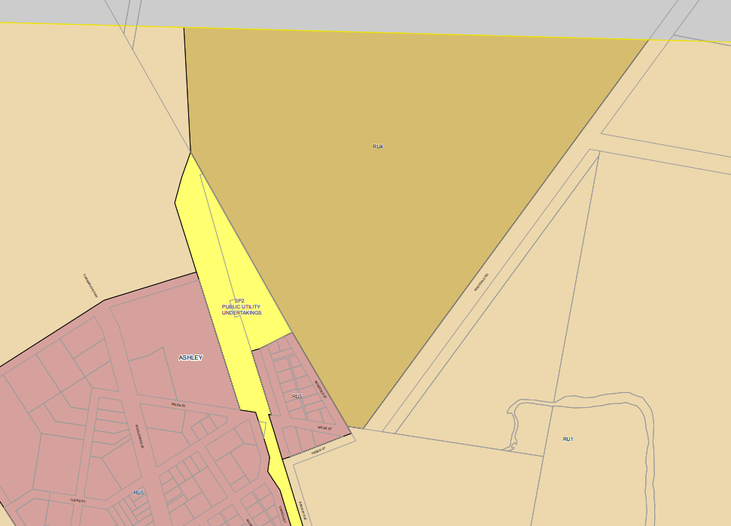
SITE
Figure 5: Land use zoning excerpt from LEP Map LNZ_004A
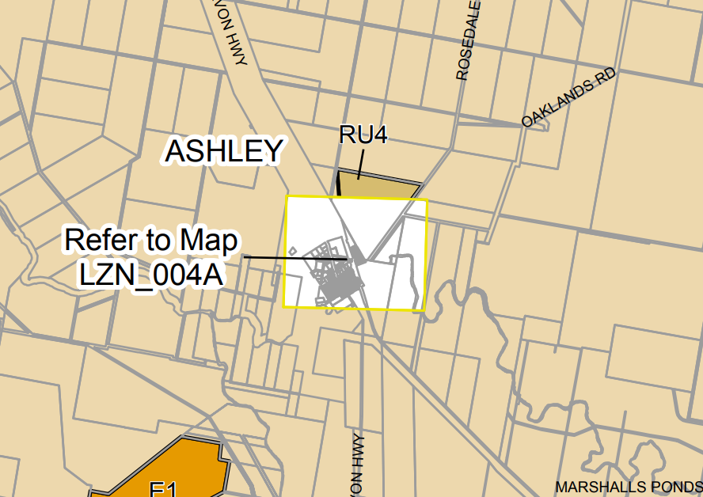
Figure 6: Land use zoning excerpt from LEP Map LNZ_004A
SITE
According to the land use terms contained in Clause 3 of the RU1 Zone (and defined in the Dictionary), the proposal satisfies the definition of electricity generating works which is a permissible use with consent as ‘Any other development no specified in item 2 or 4’ of the Land Use Table in Clause 2.3.

According to the land use terms contained in Clause 3 of the RU4 Zone (and defined in the Dictionary), the proposal satisfies the definition of electricity generating works which is permissible with consent within the Land Use Table in Clause 2.3.

Pursuant to Clause 2.36(1)(b) of the State Environmental Planning Policy (Transport and Infrastructure) 2021 the proposed development is permissible with consent with a prescribed zone in which the RU1 and RU4 zones are identified under Clause 2.35.

The zone objectives for both the RU1 and RU4 zone area as follows (pursuant to the Land Use Table in Clause 2.3):

Zone RU1 Primary Production

• To encourage sustainable primary industry production by maintaining and enhancing the natural resource base.
• To encourage diversity in primary industry enterprises and systems appropriate for the area.
• To minimise the fragmentation and alienation of resource lands.
• To minimise conflict between land uses within this zone and land uses within adjoining zones.
• To permit development for certain purposes if it can be demonstrated that suitable land or premises are not available elsewhere.
• To protect significant agricultural resources in recognition of their value to the longer term economic sustainability of Moree Plains.
• To maintain the rural character of the land.

Zone RU4 Primary Production Small Lots

• To enable sustainable primary industry and other compatible land uses.
• To encourage and promote diversity and employment opportunities in relation to primary industry enterprises, particularly those that require smaller lots or that are more intensive in nature.
• To minimise conflict between land uses within this zone and land uses within adjoining zones.

The proposal is considered to be consistent with these zone objectives for the following reasons:

- The development proposal does not result in the fragmentation of agricultural land nor result in land use conflict between adjoining zones;
- The development proposal encourages sustainable energy production and diversifies the economic and commercial enterprises and employment opportunities within the municipality; and
- The rural character of the locality is not significantly compromised as a result of the development.

General Controls and Development Standards (Part 2, 4, 5 and 6)

The LEP also contains controls relating to development standards, miscellaneous provisions and local provisions. The controls relevant to the proposal are considered in Table 4 below.

Table 4: Consideration of the LEP Controls
Control | Requirement | Proposal | Comply
Minimum subdivision Lot size  (Cl 4.1) | RU4 zoned land – 10ha RU1 zoned land – 100ha | The proposal does not include subdivision nor the construction of a dwelling. The MLS is not applicable for this development. | NA
Height of buildings  (Cl 4.3(2)) | Not mapped | The site is not mapped with a maximum building height restriction. The maximum height of the solar panel at full tilt is 2.5m This is considered appropriate. | NA
FSR  (Cl 4.4(2)) | Not mapped |  | NA
Land acquisition (Cl 5.1/5.1A) | Not Mapped |  | NA
Heritage  (Cl 5.10) | Not mapped | The site is not identified as being a heritage item or within a heritage conservation area. The closest heritage item to the site is located west and identified as I004 – “Midkin Homestead”.  The development proposal is not considered to impact upon the heritage item.  An AHIMS search was conducted of the site with a 50m buffer. The search did not return any Aboriginal sites or places within the search area. Given the disturbed nature of the site, it is considered unlikely that any Aboriginal objects or artefacts would be disturbed. However, should an object be unearthed during construction, all works are to cease and the relevant authority notified. | Yes
Flood Planning (Cl 5.21) | Flood studies have not been carried out for this site; however the site is mapped as subject to inundation based on the 1976 Flood event.  The site is identified as flood prone land | A flood impact assessment was completed and issued to Council. The report concluded that the site area during a 1% AEP event is flood free. The Report notes that the site may potentially become inundated during very rare to extreme flood conditions and would be limited to shallow and low hazard flood inundation. The report confirms that the development is suitable for the flood hazard and additional mitigation measures are not warranted. | Yes
Earthworks  (Cl 7.1) | To ensure that earthworks for which development consent is required will not have a detrimental impact on environmental functions and processes, neighbouring uses, cultural or heritage items or features of the surrounding land | The earthworks associated with the development are the upgrade to the access road, the installation hardstand surface and installation of PV Panels.  The works increases the impervious area across the site. A stormwater management system has been prepared to manage disruption to existing drainage patterns. The stormwater plan is to be updated to consider overland flow paths and concentrate flows and demonstrate the post development run-off is less than pre-development flows  The development does not incorporate fill.  The likelihood of disturbance of relics has been addressed under Clause 5.10. | Yes

The proposal is considered to be generally consistent with the LEP.

  - Section 4.15 (1)(a)(ii) - Provisions of any Proposed Instruments
There are several proposed instruments which have been the subject of public consultation under the EP&A Act, and which may be relevant to the proposal, including the following:

- Draft Environment SEPP
The NSW government has been working towards developing a new State Environmental Planning Policy (SEPP) for the protection and management of our natural environment. These areas are important to communities in delivering opportunities for physical health, economic security and cultural identity. Changes proposed include consolidating the following seven existing SEPPs:
- State Environmental Planning Policy No. 19 – Bushland in Urban Areas
- State Environmental Planning Policy (Sydney Drinking Water Catchment) 2011
- State Environmental Planning Policy No. 50 – Canal Estate Development
- Greater Metropolitan Regional Environmental Plan No. 2 – Georges River Catchment
- Sydney Regional Environmental Plan No. 20 – Hawkesbury-Nepean River (No.2-1997)
- Sydney Regional Environmental Plan (Sydney Harbour Catchment) 2005
- Willandra Lakes Regional Environmental Plan No. 1 – World Heritage Property.
The current provisions of the seven SEPPs listed above do not apply to the development. Accordingly, the Draft Environmental SEPP is considered not applicable in this instance.
- Draft Remediation of Land SEPP
Public comment on an explanation of intended effect for a new Remediation of Land SEPP and draft planning guidelines was on public exhibition between 31 January 2018 to 13 April 2018. The Department is in the process of identifying and considering issued identified in the submissions received. As such, considering the development does not pose an increased risk to health as a result of contaminated land, further consideration of the Draft Remediation of Land SEPP is not warranted.
These proposed instruments are considered not relevant to the application.

  - Section 4.15(1)(a)(iii) - Provisions of any Development Control Plan

The following Development Control Plan is relevant to this application:

- Moree Plains Development Control Plan 2013 (‘the DCP’)

The following DCP Chapters apply to the development proposal:

- Chapter 2 – Parking
- Chapter 4 – Moree and Environs Floodplain Development and Management
- Chapter 8 – Industrial Subdivision and Development
- Chapter 9 – Rural Development.

The proposed development is consistent with the controls set out by the relevant DCP Chapters. The development proposal does not seek variations from the controls. This is detailed within Attachment 1 – DCP Compliance Table – Rosedale Road Solar Farm

Construction level documentation will be required to the satisfaction of Council for the following matters:

- Carparking, driveway and hardstand surface to be in accordance with the conditions recommend by Council Engineers.
- Bushfire management plan and additional detail required as per recommend conditions by RFS
- Details of materials for Operation and Maintenance Shed.

The proposed development is consistent with the Moree Plains Development Control 2013.

The following contributions plans are relevant pursuant to Section 7.18 of the EP&A Act and have been considered in the recommended conditions (notwithstanding Contributions plans are not DCPs they are required to be considered):

- Moree Plains Shire Council Section 94A Development Contributions Plan 2006 (amended 2016)

This Contributions Plan has been considered and included the recommended draft consent conditions

  - Section 4.15(1)(a)(iiia) – Planning agreements under Section 7.4 of the EP&A Act

There are no planning agreements relevant to the subject site.

  - Section 4.15(1)(a)(iv) - Provisions of Regulations

Clause 61 of the EP&A Regulation 2021 contains matters that must be taken into consideration by a consent authority in determining a development application, comprising the following:
Item | Provision | Assessment
61 (1) | In determining a development application for the demolition of a building, the consent authority must consider the Australian Standard AS 2601—2001: The Demolition of Structures. | N/A  The development proposal does not include demolition.
61 (2)(a) | In determining a development application for the carrying out of development on land that is subject to a subdivision order under the Act, Schedule 7, the consent authority must consider—  (a) the subdivision order, and | N/A  The development does not subject to a subdivision order.
61 (2)(b) | (b) any development plan prepared for the land by a relevant authority under that Schedule. | N/A  As above.
61 (3)(a) | In determining a development application for development on the following land, the consent authority must consider the Dark Sky Planning Guideline—  (a) land in the local government area of Coonamble, Gilgandra or Warrumbungle Shire or in the part of the local government area of Dubbo Regional that was formerly in the City of Dubbo, | N/A  The subject site is not located within a LGA listed under 61 (3)(a).
61 (3)(b) | (b) land less than 200 kilometres from the Siding Spring Observatory, if the development is—  (i) State significant development, or  (ii) designated development, or  (iii) development specified in State Environmental Planning Policy (State and Regional Development) 2011, Schedule 7. | N/A  The subject site is not located within 200km of Sliding Spring Observatory.
61 (4) | In determining a development application for development for the purposes of a manor house or multi dwelling housing (terraces), the consent authority must consider the Low Rise Housing Diversity Design Guide for Development Applications published by the Department in July 2020. | N/A  The development proposal does not related to a manor house or multi dwelling housing (terraces).
61 (5) | Subsection (4) applies only if the consent authority is satisfied there is not a development control plan that adequately addresses the development. | N/A  As above.
61 (6) | In determining a development application for development for the erection of a building for residential purposes on land in Penrith City Centre, within the meaning of Penrith Local Environmental Plan 2010, the consent authority must consider the Development Assessment Guideline: An Adaptive Response to Flood Risk Management for Residential Development in the Penrith City Centre published by the Department on 28 June 2019. | N/A  The development application does not relate to land in Penrith City Centre.
61 (7) | In determining a development application for development on land to which Wagga Wagga Local Environmental Plan 2010 applies, the consent authority must consider whether the development is consistent with the Wagga Wagga Special Activation Precinct Master Plan published by the Department in May 2021 | N/A  The subject site is not land to which the Wagga Wagga LEP 2010 applies.
61 (8) | Subsection (7) does not apply to a development application made on or after 31 March 2022. | As above.

No draft conditions of consent are required to address Section 61 of the EP&A Regulation 2021.
  - Section 4.15(1)(b) - Likely Impacts of Development

The likely impacts of that development, including environmental impacts on both the natural and built environments, and social and economic impacts in the locality must be considered. In this regard, potential impacts related to the proposal have been considered in response to SEPPs, LEP and DCP controls outlined above and the Key Issues section below.

The consideration of impacts on the natural and built environments includes the following:

- Context and setting –

The development proposal is considered to be appropriate for the locality and setting, being appropriate in both size and scale for the rural locality. The Development Application has taken into consideration the rural landscape, and in accordance with the Visual Analysis and Reflectivity Statement, the development is not considered to result in an adverse impact. Appropriate boundary offsets are provided and whilst a change to the rural landscape will occur as a result of the development the impact is not considered significant which requires mitigation landscaping or increased boundary offsets. The development is not considered to detract from the rural landscape and is compatible with the existing land uses. No impacts on adjoining landowners has been identified.

Consideration was given to the proposed development in proximity to the railway and potential safety impacts on the rail network as a result of reflection and glare. ARTC were notified for comment to address any concerns surrounding glare and impact to rail safety. No response was provided. Accordingly, it is considered that the recommendation from the Visual Analysis and Reflectivity Statement to avoid the possibility of nuisance glare for southbound rail traffic should be implement during fixed position construction and maintenance. This is referenced in Condition B13 of the draft conditions of consent.

Reference was made to the night-time illumination of an Operation and Maintenance Building, power conversion unit, fire access routes and egress. Whilst it is noted that the solar farm proposed 24 hour a day operation, it is considered that 24 hour lighting of the listed facilities is not necessary. Night-time lighting of the facility could be managed by sensor lighting. Accordingly, it is not considered necessary to approve 24 hour lighting under the current Development Application. Should 24 hour lighting be proposed further application for the installation of lighting is required as detailed by Condition B13.

The Appendix C of the Statement of Environmental Effects states that the proposed development does not include the construction of a building. Yet, the development plans and subconsultant reports make reference to the operation and maintenance building. The Council do not identify any environmental impacts as a result of the proposed shed (28m² GFA). In order to minimise impact on the rural landscape, the Council impose that the shed be constructed of non-reflective muted tones as referenced in Condition F5.

- Access and traffic

Traffic Generation
A traffic impact assessment (TIA) was prepared by Intersect Traffic, which assesses the potential traffic impacts associated with the proposed development. In summary the proposed development will create additional localised traffic movements during construction of the solar farm. After construction is completed, the development will have negligible traffic impact. The traffic associated with the ongoing operation of the facility is limited to maintenance staff which is proposed to one employee. Council Engineers assessed the traffic impact assessment and deemed as suitable. Accordingly, Rosedale Road has the capacity to accommodate the localised traffic generation. No road upgrades or intersection improvements are identified as necessary for the purpose of the development proposal. Council Engineers have prohibit heavy vehicle movements from Rosedale Road onto the site during School transport hours. Condition B6 details the restriction to heavy vehicle traffic movements to the following hours:

Before 7am
9am to 2.30pm
After 5pm

Access and carparking
The proposed access to the subject site area is via the existing entry point from Rosedale Road in the south-east corner of the allotment. The access travels along the west boundary before travelling north along the existing vegetation. At the entry point of the site area, formalised access will be created with associated hardstand surface and carparking.

As detailed above, the access to the site is deemed suitable to Council without upgrade to Rosedale Road. Heavy vehicle movements will be required by permit approval and restricted in accordance with Conditions B3 and B6 respectively. In accordance with the Engineering Response, the development is required to meet the relevant Australian Standards for driveway access, off-street parking. Conditions B11 and B14 detail the necessary details to be submitted prior to the issue of a construction certificate to ensure the development meets the minimum requirements and Council Policy. The site is considered to have sufficient are to allow for safe traffic movements in a forward direction to and from the subject area. Internal directional movement signs are recommended on the hardstand surface to avoid accidental traffic collision during construction. This recommendation is detailed in Condition B12. Considering the single employee for ongoing operation and maintenance, it is considered that the traffic collision risk is low post construction.

- Public Domain

The development proposal is not identified to have an adverse impact on the public domain. The development proposal for solar electricity infrastructure does not allow for public recreation. Accordingly, there is no necessity for public or private open space to be provided as part of the project. The development is not identified to have any impact on pedestrian linkages in the area nor will it adversely impact public infrastructure. The contributions collected as part of this development application can be used to implement the Moree Plains Capital Works Projects.

- Utilities

The development proposal to construct a 5MW solar power farm creates energy to be connected to the grid. Referral Response from Essential Energy had no specific comments or objections to the development. Electricity Grid Connection is to be obtained as detailed in Condition E6.

The development does not seek connection to water, sewer or gas supplies.

- Heritage

The site is not identified as a heritage item or located within a heritage conservation area. The AHIMs search provided did not identify any Aboriginal sites or places within a 50m buffer of the site. A further AHIMs Search with a 1km buffer conducted on 8 February 2022 did not identify any Aboriginal sites or place within the locality. Given the highly disturbed nature of the site, and the lack of waterways present, it is considered unlikely that an Aboriginal object or artifact would be located. However, should an item be uncovered during construction, works are to cease and the relevant authority notified in accordance with Conditions B4 and D5.

- Other land resources

The site is not within a water catchment, or within a mining or mine subsidence district. The site is located on agricultural land. The solar farm comprises an area of approximately 15.2 ha of the subject site which measures approximately 247 ha. This equates to 6% of the agricultural land. Whilst the proposed development will utilise 6% of the total potential agricultural land, this development provides a positive economic and environmental impact through:
  - Create of construction jobs and monetary input into the construction industry
  - An ongoing revenue stream for the landowner through the lease agreement. The money generated through the lease agreement can be used to improve farming operations.
  - The development actively combats the impacts of climate change by providing a renewable energy source into the grid.

The proposed development is considered to have a net environmental and economic benefit whilst allowing 94% of the allotment to be retained for traditional agricultural purposes.

- Water/air/soils impacts

Contamination
The site is not identified as being land subject to contamination in accordance with SEPP No.55. Whilst herbicides and pesticides are likely to have been used in the locality, the proposed use and ongoing maintenance is not identified to result in unreasonable contamination exposure which will risk human health. The development is not considered to increase risk of exposure. Given the cultivated land, it is unlikely that large contaminants such as asbestos are likely to present. To this extent, the site is considered fit for the intended purpose.

Water
The development increases the impervious area of the site and therefore stormwater generation and overland flows will alter as a result. The Council Engineers were satisfied with the stormwater management address of post-development flows and impacts from the internal road network. Condition B9 requires the applicant to provide final design plans for the stormwater drainage systems prior to the release of the Construction Certificate.

Air quality
The construction of the proposed development is likely to generate localised air quality impacts as a result of additional truck movements and associated dust generation. Given the proximity to residential neighbours, the development is not anticipated to result in any adverse health impacts. After construction of the solar farm, revegetation of the site under the solar panels is proposed which will limit ongoing dust generation and associated air quality impacts.

- Flora and fauna impacts

The site area is cleared of vegetation as a result of ongoing farming operations. Consultation with the Biodiversity Conservation Department (BCD) was held with regard to vegetation removal without a permit. The BCD were of the opinion that had an application been made to remove the vegetation it would have been granted. The vegetation was classified with low biodiversity value, accordingly no further action was required by the BCD to manage impact. The development proposal does not identify any additional tree removal. As such there are no identified impacts on the local koala population or threated species. The development will result in the removal of ground cover during construction. The ground cover is to be re-established at the conclusion of the construction. To this extent, no significant adverse biodiversity impacts have been identified.

- Natural environment

The topography of the site is flat with natural drainage occurring to the south and east of the site. The proposed development includes earthworks to establish the hardstand surface for the car parking area and the foundation of the operation and maintenance shed. The proposal does not result in any significant changes to the natural contours of the site.

- Noise and vibration

The Noise Assessment by Muller Acoustic Consultant takes into consideration construction noise, operational noise and noise impacts arising from road traffic. The report concluded that construction noise levels at nearby sensitive receivers are compliant with NML Standard. Similarly, operational noise levels are compliant with the PNTL Standards. The report has taken a conservative approach to traffic noise, which assumed four heavy vehicles per hour and 20 light commercial vehicles during morning and afternoon peak periods. The heavy vehicle movements anticipated in accordance with Appendix C of the Traffic Impact Assessment prepared by Intersect Traffic indicates that the heavy vehicle movements are limited eight per day. It is noted that the Noise Assessment assumes entry to the site from Carnarvon Highway whereas the entry to the site is via Rosedale Road. Despite this, the sensitive receivers remain consistent through the approach to the site via North Road. Accordingly, the noise impacts identified in the report related to traffic noise are suitable and within acceptable tolerance limits.

In conclusion, the noise impacts are limited to the construction of the solar farm; no operational noise impacts are identified. Accordingly, the recommendations made within Section 7 of the MAC Acoustic Assessment (April 2021) should be implemented to reduce potential construction noise impacts on sensitive receivers. This matter is detailed under Conditions B6 and D7.

- Natural hazards

The site is identified to be subject to bushfire and inundation.

- Bushfire
The development proposal was referred to RFS for comment. The general terms of approval are detailed within Conditions B10 and F1. Implementing the recommended conditions will limit risk to property and life as a result of a bushfire event.

- Flooding
A flood impact assessment was prepared for the proposed development. The subject area is not subject to the 1% AEP flood events. Rare or extreme events may result in shallow low hazard inundation of the development footprint. The development proposal is not for a habitable building, therefore minimum finished floor levels in this instance are not applicable. Negligible risk of increased loads as a result of debris flowing through flood waters, placing increase structural loads on the equipment, shed and fencing have been identified. This matter is detailed under Condition B15.

- Safety, security and crime prevention

There are no associated safety, security or crime impacts associated with the proposed development. The site is securely fenced to mitigate trespass opportunities. Vegetation is limited to avoid overshadowing the solar panels during the day, accordingly, the lack of vegetation limits visually obscured areas which could encourage criminal behaviour. Given the location it is not considered that CCTV monitoring is necessary. Should vandalism or other criminal acts occur on site, CCTV can be retrospectively installed. The development is not considered to increase criminal risk to person which is not already present on the site.

- Social impact

Perception of health and sense of place contribute to the overall social health of a community. Climate change is a ‘wicked’ global issue that results in significant angst in a range of populations. Farming communities are one of the first communities to see and feel the impacts of climate change. This is known to have a direct impact on the mental health of agricultural land owners. In recent times, the Moree Plains Local Government Area has experienced both drought and flood. The extreme environmental events have been attributed to ongoing climate change and the enhanced greenhouse effect. The proposed development for a solar power farm to contribute to renewable energy infrastructure actively seeks to combat the impacts of climate change and contribute to the global objectives of reducing carbon emissions. Indirectly, the development will have positive social impacts through the community by visually representing the combat against climate change. It is considered that the development has the potential to increase the ‘sense of place’ for the Ashley community and the broader Moree Plains LGA. The development is also expected to have positive environmental impacts which indirectly has a positive impact on physical and mental health.

The proposed development on the rural landscape has the potential to alter the perception of place in Ashley. It is considered that the proposed development does not result in substantial visual impacts on rural landscape. The SoEE details that community consultation was conducted and visual impact on the rural landscape was a matter of community concern. Given the offset from the public domain and lack of community submissions during the exhibition period, it is concluded that the community are satisfied that the development on rural landscape is satisfactory. Thus, to this extent, the development is considered to have a low potential to adversely impact the perception of place in Ashley.

The proposed development will create construction jobs and monetary expenditure within the Moree Plains LGA. This contributes to job security and in turn has positive health and social impacts for the community.

Overall the development is considered to have a positive social impact.

- Economic impact

The proposed development is anticipated to generate 30 construction jobs for a six month period with one ongoing mangers position to be held for the ongoing operation and maintenance of the facility. The job generation will have a positive economic impact for local construction operators. It is anticipated that expenditure in local businesses will occur as a result. The development is considered to have positive economic impact.

- Site design and internal design

The development is considered to sited appropriately to mitigate visual impacts on the public domain. Access and traffic impacts can be suitably managed in accordance with the imposed conditions.

- Construction

Hours of construction are to occur as detailed below and under Condition D1

Monday – Friday 7am to 6pm
Saturday 8am to 1pm

No work to be conducted on Sunday or public holidays

- Cumulative impacts

The development is consistent with planning controls and no cumulative impacts have been identified during the assessment.

Accordingly, it is considered that the proposal will not result in any significant adverse impacts in the locality as outlined above.

  - Section 4.15(1)(c) - Suitability of the site

The proposed development is a suitable use of the site. The application design includes all elements required under the relevant planning instruments and policies and there are negligible anticipated adverse impacts on the locality as a result of the development that cannot be managed or mitigated through imposition of consent conditions. This development is permissible under the LEP and has addressed any relevant concerns. As such the site is considered suitable for the intended purpose.

  - Section 4.15(1)(d) - Public Submissions

No public submissions were received during the notification period.

  - Section 4.15(1)(e) - Public interest

The site has access to all relevant services and the proposed development makes good use of the available land without jeopardising the agricultural viability of the land. The application design includes all elements required under the relevant planning instruments and policies and there are no anticipated negative impacts on the locality that cannot be managed or mitigated.

As detailed above, the proposed development is identified to have a number of positive social and economic impacts which support the proposed development. No submissions from the public were made during the exhibition period, as such it is considered that the public are not opposed to the development. As detailed above, the proposed development actively fights climate change and supports the government initiatives to reduce carbon emissions and increase renewable energy infrastructure.

To this extent, the development is in the public interest.

- REFERRALS AND SUBMISSIONS

  - Agency Referrals and Concurrence

The development application has been referred to various agencies for comment/concurrence/referral as required by the EP&A Act and outlined below in Table 5.
There are no outstanding issues arising from these concurrence and referral requirements subject to the imposition of the recommended conditions of consent being imposed.

Table 5: Concurrence and Referrals to agencies
Agency | Concurrence/  referral trigger | Comments  (Issue, resolution, conditions) | Resolved
Concurrence Requirements (s4.13 of EP&A Act)
Environment Agency Head (Environment, Energy & Science Group within DPIE) | S7.12(2) - Biodiversity Conservation Act 2016 | The proposal does not include vegetation removal and therefore it was concluded that there were no tangible impacts on biodiversity. Referral to the Environment Agency Head was not warranted. | NA
Rail authority for the rail corridor | Cl 86(3) - State Environmental Planning Policy (Infrastructure) 2007 | The proposal includes development in proximity to a rail corridor. Referral to ARTC was conduction. No response was received. It is considered that no concerns or matters require addressing as part of this application. | Y
Referral/Consultation Agencies
RFS | S4.14 – EP&A Act  Development on bushfire prone land | The site is identified as bushfire prone land. Referral was made to RFS and response was received. The general terms of approval can be conditions without further information required at DA stage. Draft conditions are provided. | Y
Electricity supply authority | Cl 2.48 – T & I SEPP  Development near electrical infrastructure | Referral to Essential Energy was made and response received. Essential Energy had no comments to make as to potential  safety risks arising from the proposed development. General comments were made in association with the development. Draft conditions are provided. | Y
Rail authority | Cl 2.97 – T & I SEPP  Development land that is in or adjacent to a rail corridor. | As above. | Y
Transport for NSW | Cl 2.121 – T & I SEPP  Development that is deemed to be traffic generating development in Schedule 3. |  | NA
Transport for NSW | Cl 3.16 – I & E SEPP  Advertisement within 250m of classified road any part of which is visible from the classified road and subject to Cl 17. |  | NA
Design Review Panel | Cl 28(2)(a) – SEPP 65  Advice of the Design Review Panel (‘DRP’) |  | NA
Integrated Development (S 4.46 of the EP&A Act)
RFS | S100B - Rural Fires Act 1997  bush fire safety of subdivision of land that could lawfully be used for residential or rural residential purposes or development of land for special fire protection purposes |  | NA
Transport for NSW | S138 - Roads Act 1993 for works in the road reserve. |  | NA
Heritage NSW | S58 of the Heritage Act 1977 for demolition or works etc to an item listed on State Heritage Register or with an interim heritage order. |  | NA
Natural Resources Access Regulator | S89-91 – Water Management Act 2000  water use approval, water management work approval or activity approval under Part 3 of Chapter 3 |  | NA

  - Council Referrals

The development application has been referred to various Council officers for technical review as outlined Table 6.

Table 6: Consideration of Council Referrals
Officer | Comments | Resolved
Engineering | Council’s Engineering Officer reviewed the submitted stormwater concept plan and architectural plans. It is considered that the land has sufficient area to managed post development stormwater through appropriate engineering design. Additional information was supplied to Council’s engineering department dated 11 February 2022. The information was considered satisfactory by Council’s engineers. Accordingly post development flows can be suitably managed.  Construction Certificate level drawings will be required to address compliance with the relevant Australian Standards. | Y
Traffic | Council’s Traffic Engineering Officer reviewed the proposal and raised concerns in relation to traffic generation and car parking. These issues are considered in more detail in the Key Issues section of this report. Condition B3 has been imposed to limit turning movements of heavy vehicles during school bus community hours to limit potential risk of collision on Rosedale Road. | Y
Building |  | NA
Health |  | NA
Waste |  | NA
Public Domain/  Assets |  | NA
Heritage |  | NA

There are no outstanding issues raised by Council officers that require further consideration prior to the determination of this application.

  - Community Consultation

The proposal was notified in accordance with the DCP/Council’s Community Participation Plan from 7 October 2021 until 29 October 2021. The notification included the following:

- Notification on the Council’s website.

The Council received a total of zero submissions. No community issues have been raised.

- KEY ISSUES

The following key issues are relevant to the assessment of this application having considered the relevant planning controls and the proposal in detail:

  - Visual Impact and Reflectivity

The development has the potential to result in visual impact on the rural landscape. The Visual Impact Assessment and Reflectivity Statement prepared by SLR considered this issue. The report considered the extent of the visual impact on the rural landscape and concluded magnitude of change and receptor sensitivity to be low. Considering the proposed offsets from the public domain, it is agreed that the development does not result in significant adverse visual impacts that require mitigation.
Operation and Maintenance Shed
The proposed operation and maintenance shed 6m long x 4m wide x 2.8m high is considered appropriate for the locality. The setback from the public domain is considered suitable and not to result in adverse landscape impacts. The building is to be constructed in non-reflective muted notes to reduce visual impact on the rural landscape.
Resolution: This matter is considered to be acceptable and requires to further action.

Reflectivity
The Reflectivity Statement identified that the development in proximity to the railway had potential safety impacts on the rail network as a result of reflection and glare. The recommendation from the Visual Analysis and Reflectivity Statement to avoid the possibility of nuisance glare for southbound rail traffic should be implemented during fixed position construction and maintenance.
Resolution: The issue is resolved through recommended conditions of consent.

Night illumination
The SoEE states that motion sensor lighting for security purposes will be installed. The Reflectivity Statement details possible 24/7 hour lighting may be implemented in the future, yet not part of the current Application. It is considered that additional detail on potential night lighting would be required under a separate Development Application.
Resolution: The issue is resolved through recommended conditions of consent.

  - Engineering – Traffic, Access and Stormwater
Stormwater
The development results in an increase in impervious area on the site. A Stormwater Management Report prepared by DRB Consulting Engineers considered this issue. Council Engineers reviewed the report and supporting plans and concluded:
- The submitted “Stormwater Management Report” (report) prepared by DRB Consulting Engineers dated 21st April 2021 does not make very clear idea how it has been achieved less stormwater runoff post development with an increase in impervious surface area.

- The Report does not consider the overland flow path of the photovoltaic cells area catchment. Consideration must be given to how the internal road network will alter flow paths and concentrate flows.
It is considered that the land has sufficient area to managed post development stormwater through appropriate engineering design. It is not anticipated that the development would result in any impact on water quality. Additional information was provided to Council dated 11 February 2022 which was to the satisfaction of Council Engineers
Construction Certificate level drawings will be required to address compliance with the relevant Australian Standards.
Resolution: The issue is resolved through recommended conditions of consent.

Traffic and Access
The proposed access to the subject site area is via the existing entry point from Rosedale Road in the south-east corner of the allotment. The access travels along the west boundary before travelling north along the existing vegetation. At the entry point of the site area, formalised access will be created with associated hardstand surface and carparking.

The access to the site is deemed suitable to Council without upgrade to Rosedale Road. Heavy vehicle movements will be restricted to outside school bus operating times as required by Council Engineers. Upgrade to the internal driveway is required to allow two way traffic movement for B-Double trucks. Traffic movements do not result in adverse noise impacts outside of acceptable tolerance limits.
Resolution: The issue is resolved through recommended conditions of consent.

  - Flooding
The site is subject to inundation. A flood impact assessment was prepared for the proposed development. The subject area is not subject to the 1% AEP flood events. Rare or extreme events may result in shallow low hazard inundation of the development footprint. Given the development proposal is for a non-habitable structure being a solar array, hardstand surface, carparking and operation and maintenance shed, it is considered that there is limited risk to life as a result of a flood event. There is limited impact resulting from the proposed development with respect to flood impacts.
Resolution: The issue is resolved through recommended conditions of consent.

  - Noise Assessment

The potential for noise and vibration to impact on adjoining properties is a consideration through the construction. The application was accompanied by a Noise Assessment prepared by Muller Acoustic Consulting, dated April 2021 (‘Noise Assessment Report’) which considered this issue.

The Noise and Vibration Report considered the noise impacts arising from the proposed construction of the development and ongoing operation. The report concluded that construction noise levels at nearby receivers are compliant with NML Standard. Similarly, operational noise levels are compliant with the PNTL Standards. The report has taken a conservative approach to traffic noise, which assumed four heavy vehicles per hour and 20 light commercial vehicles during morning and afternoon peak periods. The traffic noise impact is within accepted tolerance limits.

The report concluded that despite compliance with noise impact levels during construction, recommendations have been provided the works could proceed if a Construction Noise and Vibration Management Plan to reduce the likelihood of noise impacts due to construction activity are prepared. Council has considered this report and following a detailed assessment, concluded the report was satisfactory and construction noise impacts can be managed through the implementation of the recommendations made within the report.

Resolution: The issue is resolved through recommended conditions of consent.

- CONCLUSION

This development application has been considered in accordance with the requirements of the EP&A Act and the Regulations as outlined in this report. Following a thorough assessment of the relevant planning controls, issues raised in submissions and the key issues identified in this report, it is considered that the application can be supported.

The proposed development is considered to have a positive social and economic outcome as a result of increased construction and employment opportunities. Environmental impacts identified can be managed within acceptable tolerance limits. The development is not identified to result in substantial visual, amenity or environmental impact. To this extent, the development is considered compatible with the locality and the site suitable for the proposed development.

It is considered that the key issues as outlined in Section 6 have been resolved satisfactorily through the recommended draft conditions at Attachment 2.

- RECOMMENDATION

That the Development Application 2021/00047 for the construction of a 5MW Solar Farm at Rosedale Road be APPROVED pursuant to Section 4.16(1)(a) of the Environmental Planning and Assessment Act 1979 subject to the draft conditions of consent attached to this report at Attachment 2.

The following attachments are provided:

- Attachment 1: DCP Compliance Table.
- Attachment 2: Draft Conditions of consent

